This is for adding a new CI to an Application (called as Downstream) or an Application to be mapped under a CI (Upstream)

1. **From Apps name to map the CI’s as Downstream Relationship:**

Open Apps Server CMDB:-

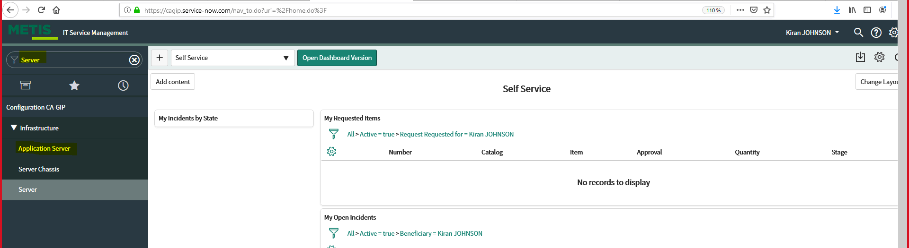

Search for the Apps name:-

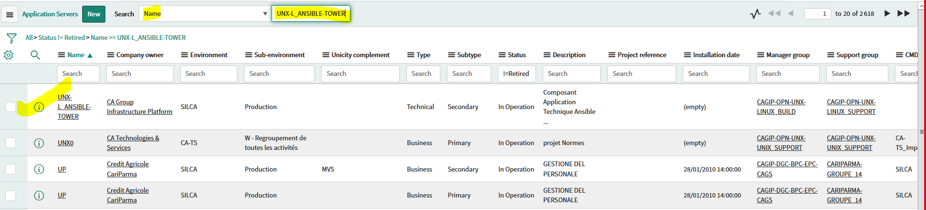

Go to CI Relationship:-

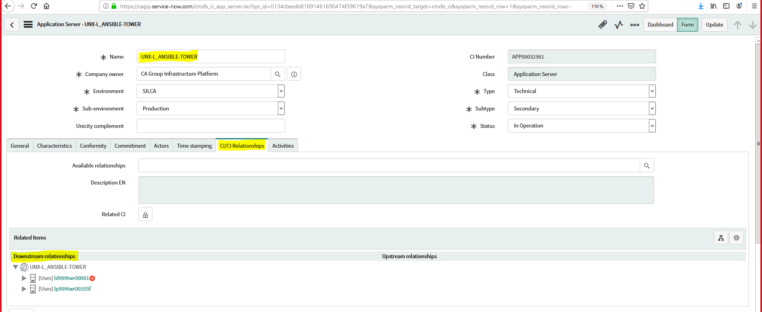

Edit and add CI as below mentioned:-

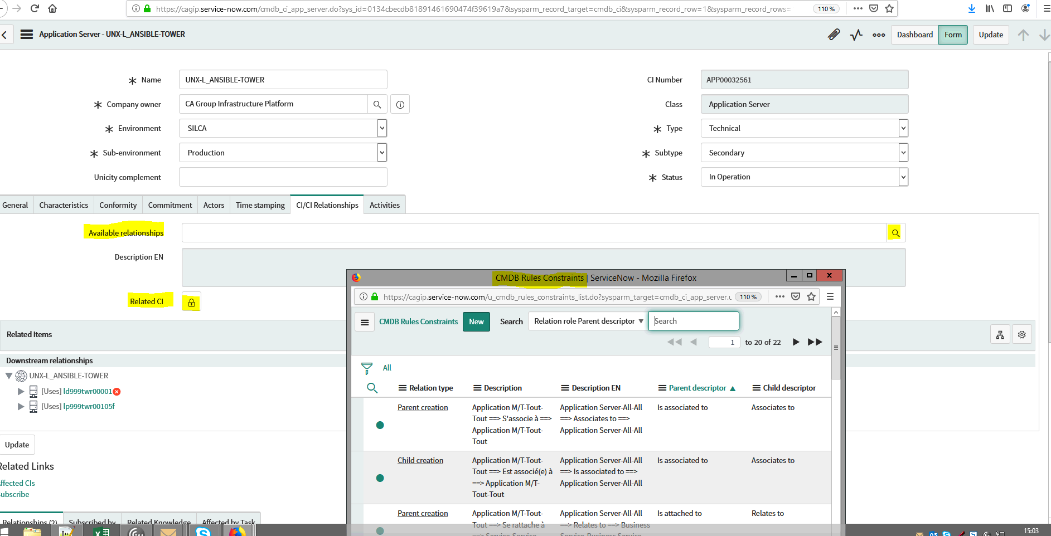

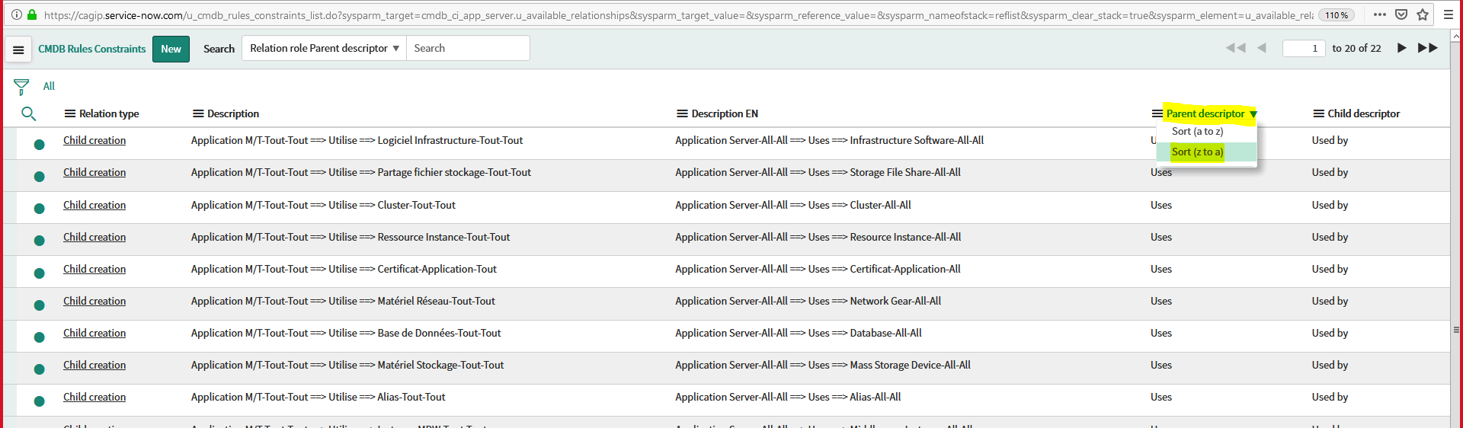

**NB:- Make sure to select the correct Category as mentioned in below Screenshot**

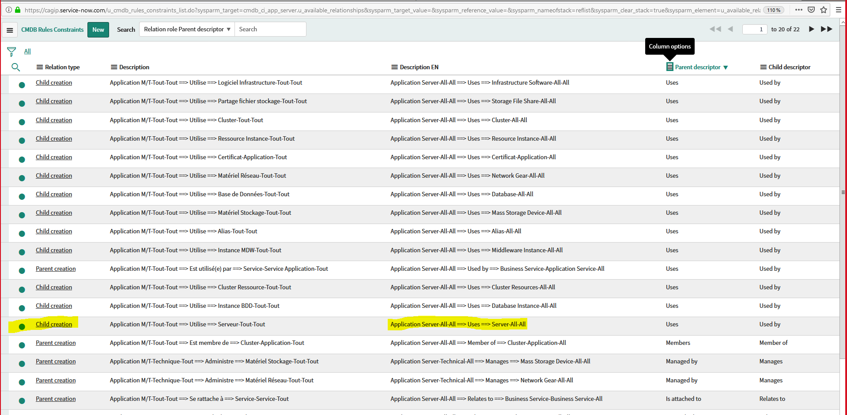

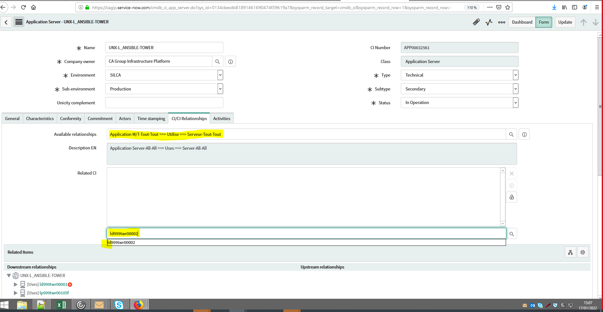

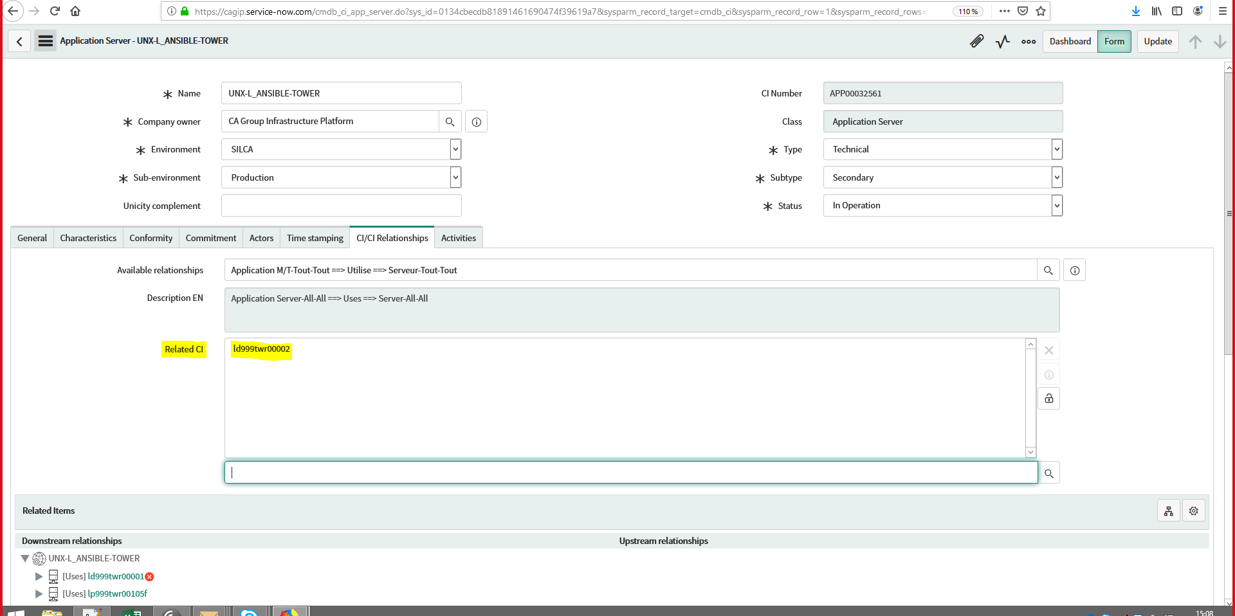

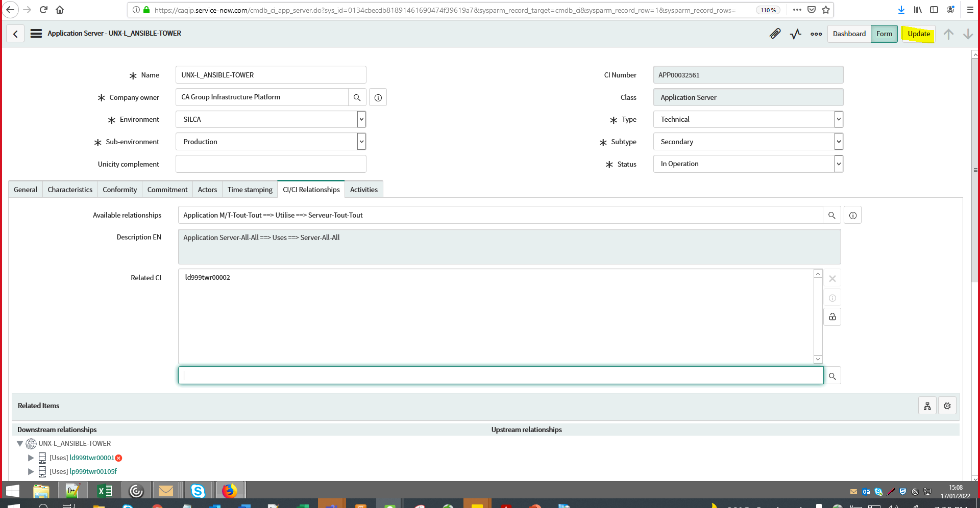

We can now see the new CI is added under the Application

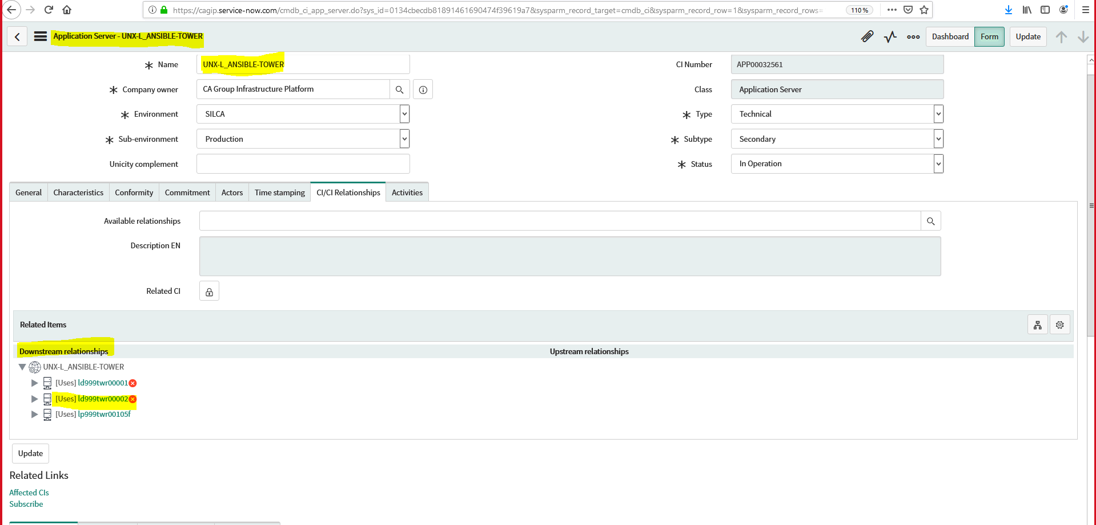

Also in the receptive CI also, the Apps name is mapped

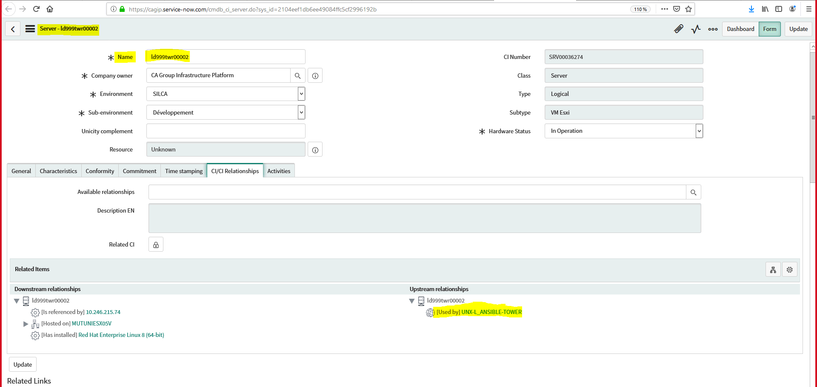

**P.T.O**

1. **From CI to map Apps name as Upstream Relationship :**

Open Server CMDB in Metis:-

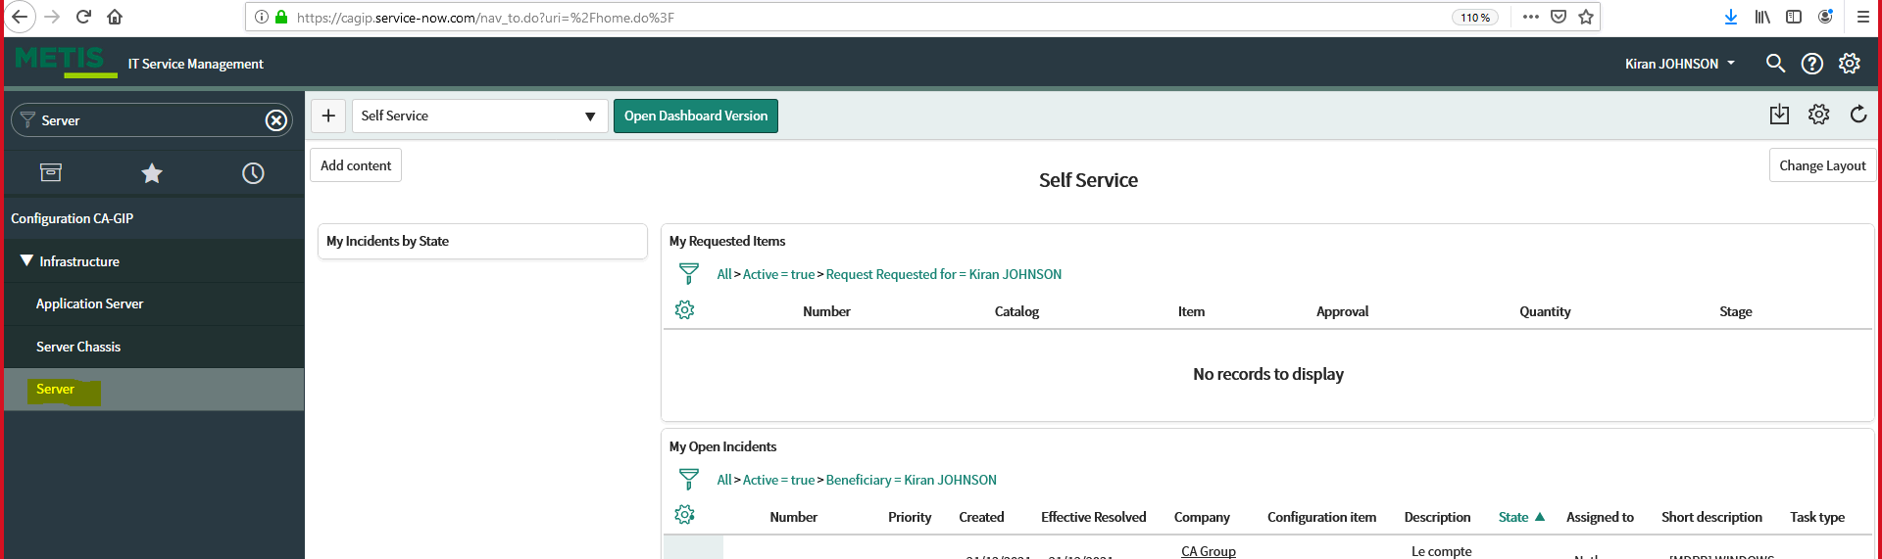

Search for the Server to be added:-

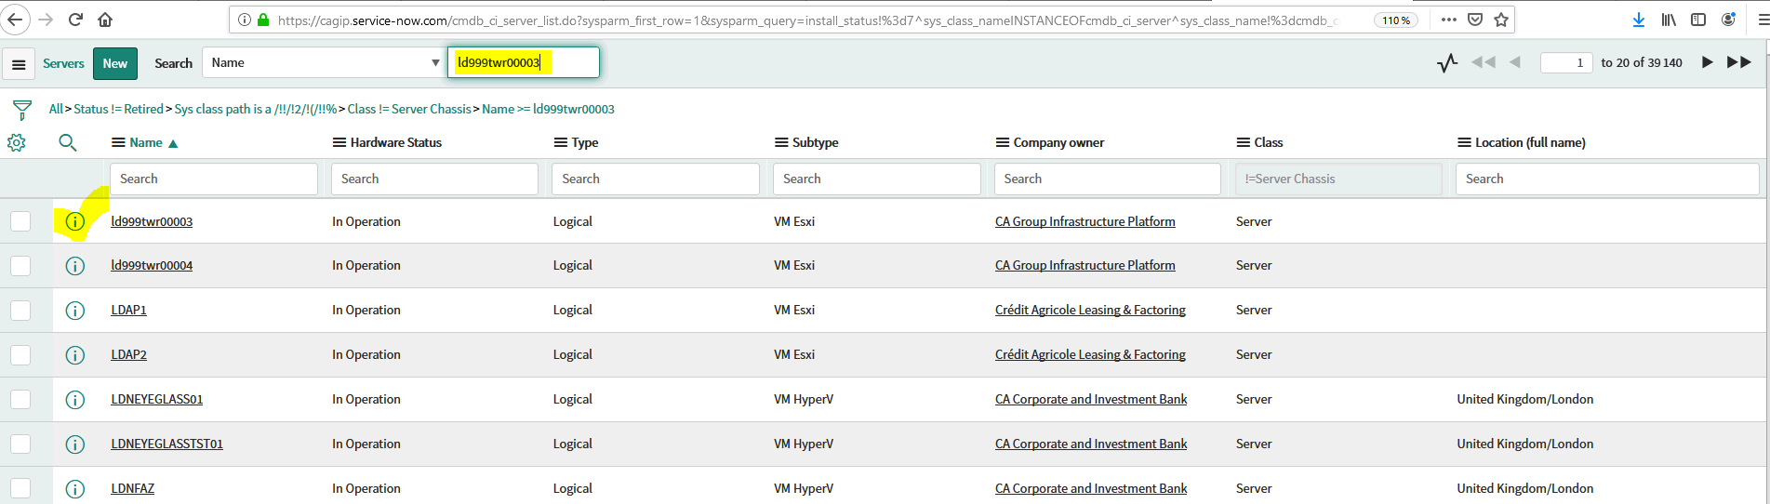

We are going to Add a Application under the Upstream relationship

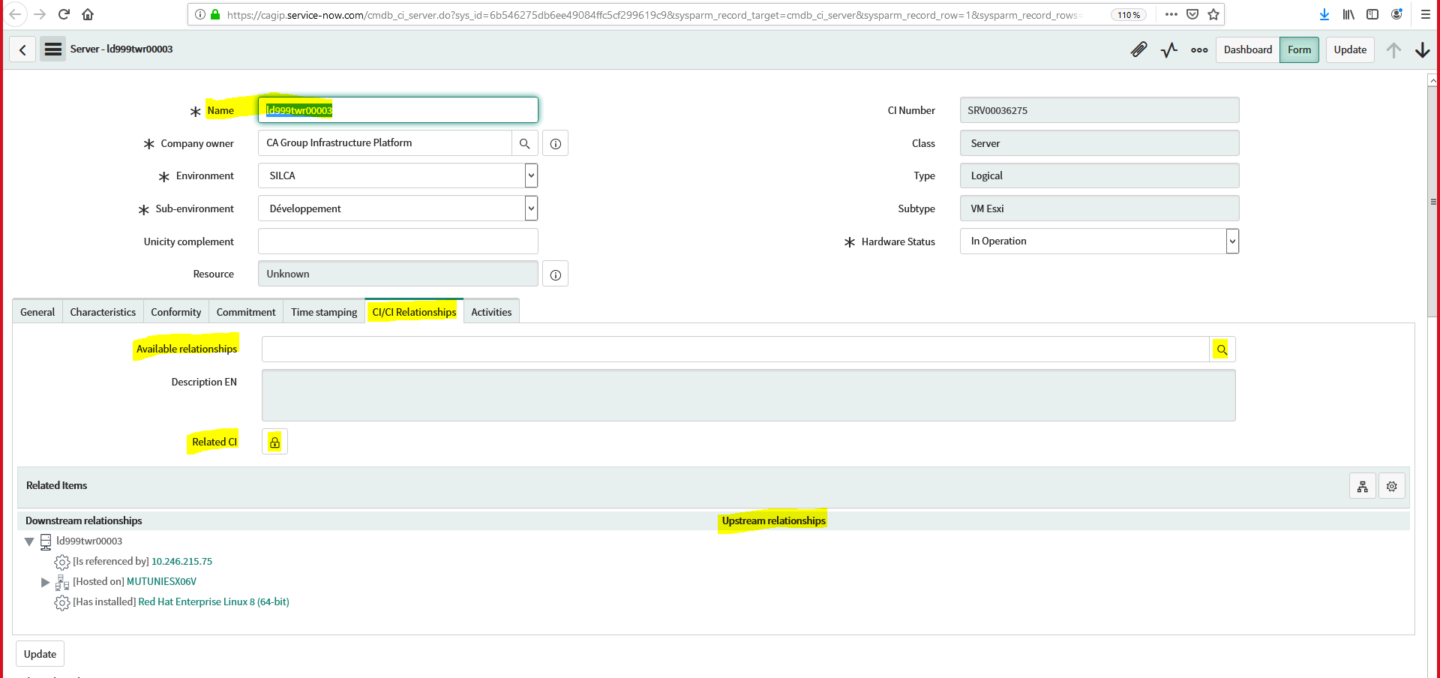

**NB:- Make sure the correct category is selected as shown below:**

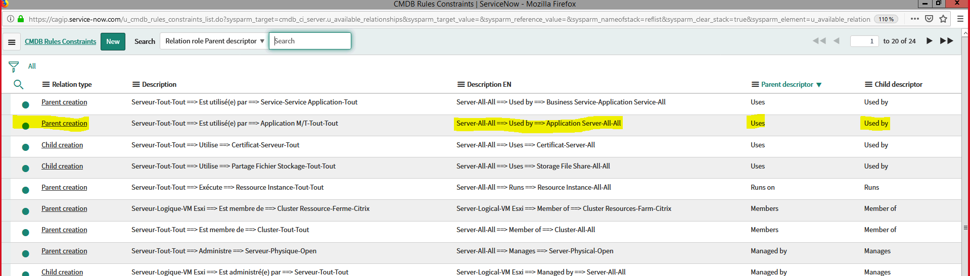

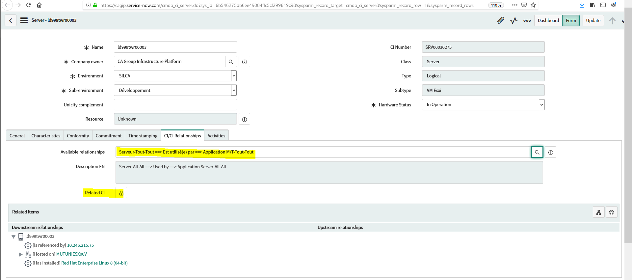

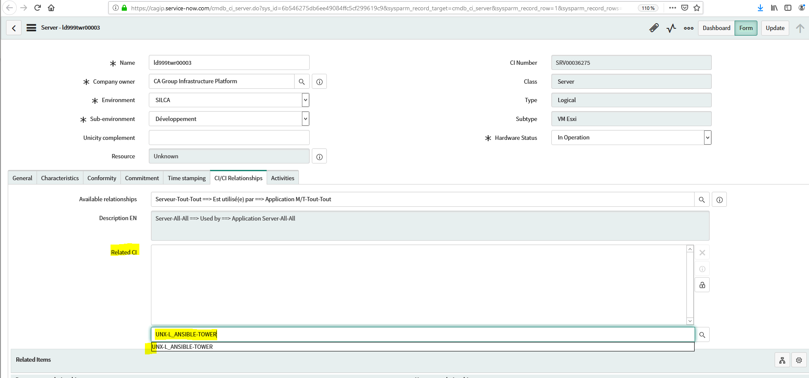

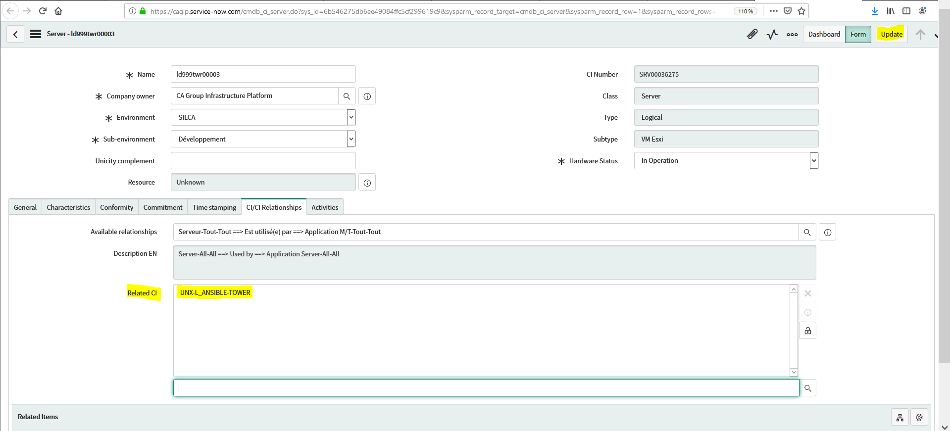

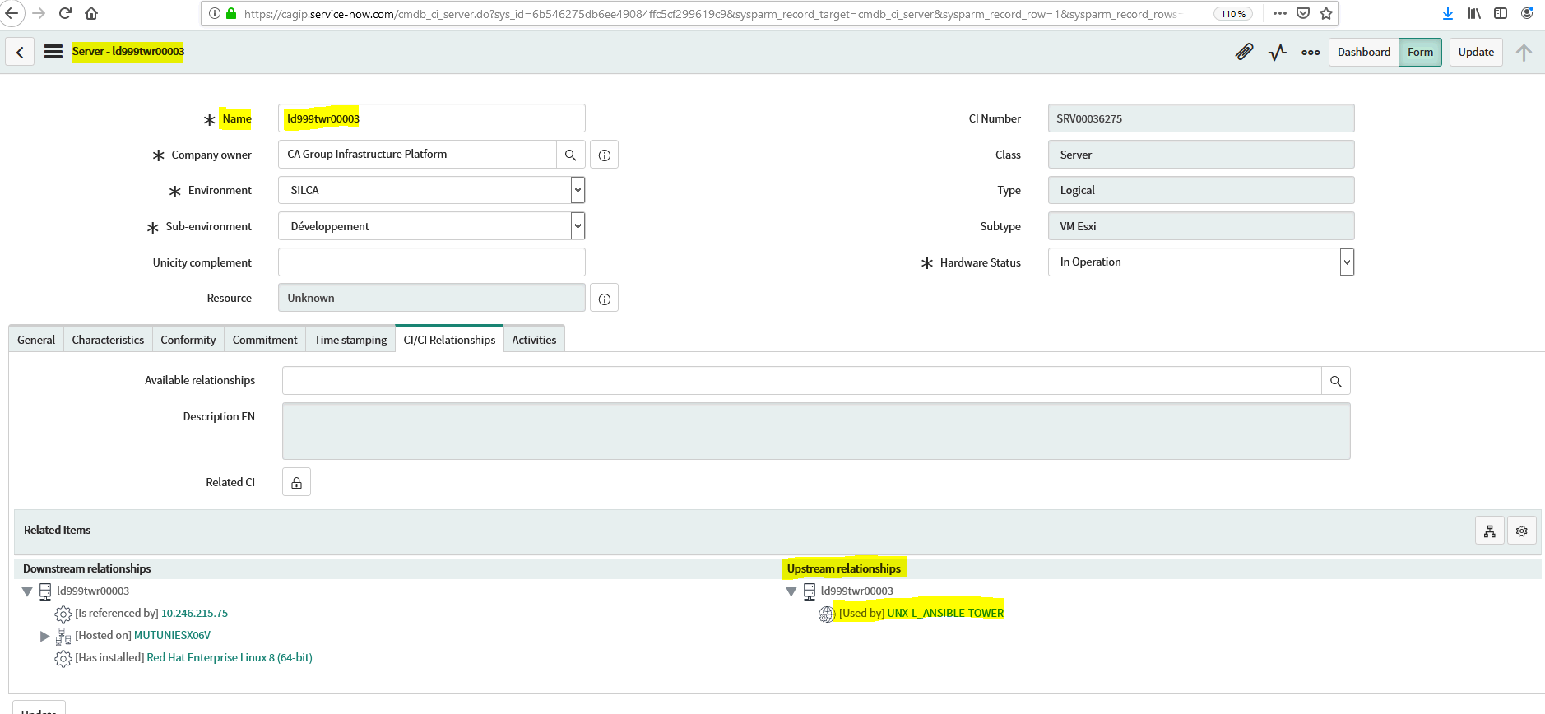

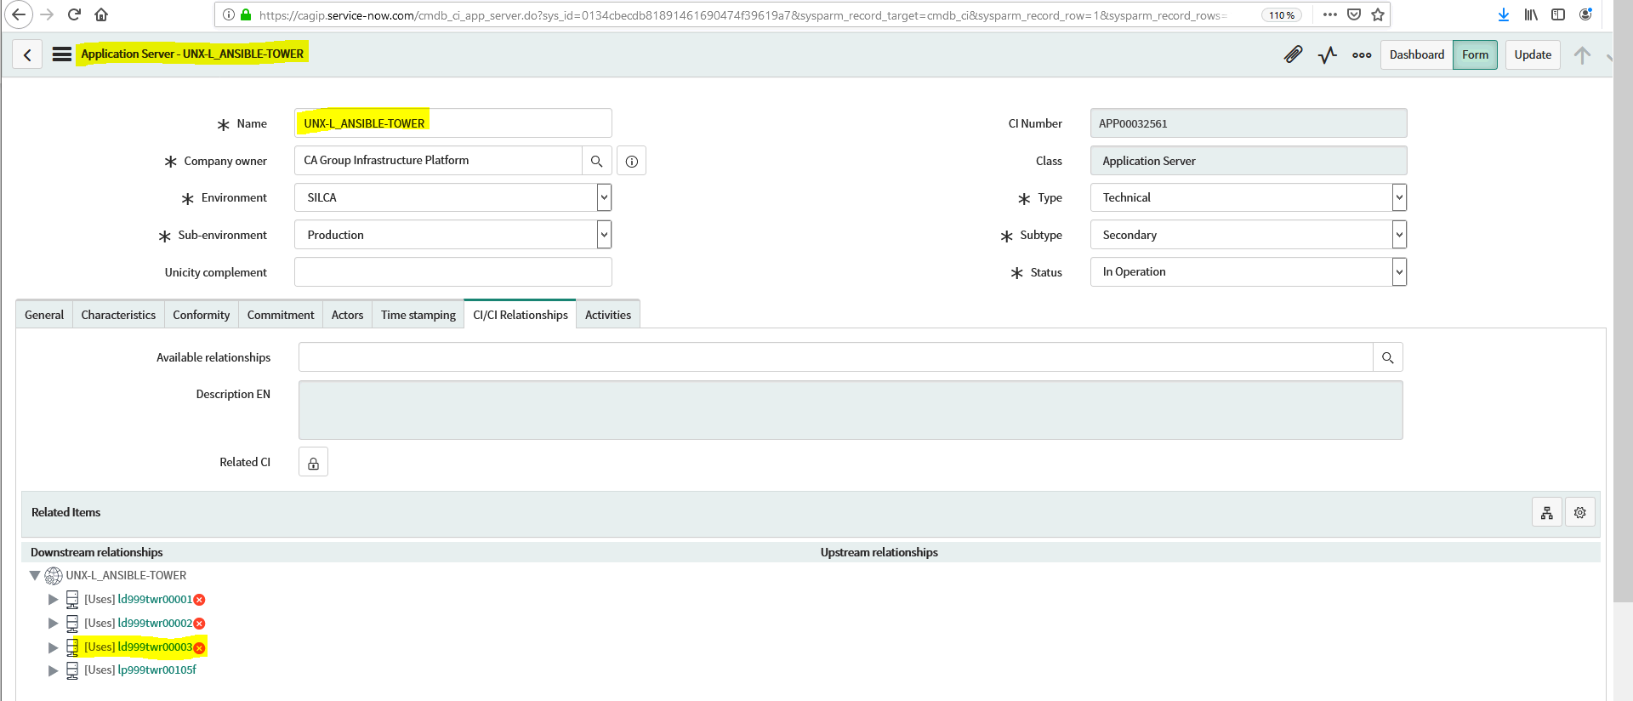

(Note :- the red close/into symbol near to CI => says it have a Snow ticket ongoing.)